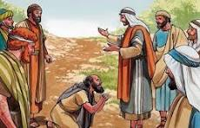

St. John the Baptist Parish

Our Lady of Perpetual Help Church

390 High St. New Glasgow, NS B2H 2X7
Telephone: 902-695-3433 Fax: 902-752-0805
E-mail: allsaint@eastlink.ca
St. Vincent de Paul Assistance
Eastside (St. John the Baptist) 902-771-2766
Westside (Our Lady of Lourdes) 902-759-1389

Served By…

Fr. Godwin Kalu, SMMM, Pastor 902-695-3107
Email: saintjohnthebaptist35@gmail.com

Rev. Mr. Sander Burke-Deacon
902-755-5510; cell 1-902-872-0704
Email: sanderburke47@gmail.com

Pat Gillis - Director Rel. Ed
902-695-3433

Maureen Willis - Secretary
902-695-3433

Robert Rogers - Office Finance

Paulette Fraser - Office Finance

Tom Mooney–Pastoral Council Chair

Gary Rankin- Finance Council Chair

Mark MacKenzie– Organist/Custodian

28th Sunday in Ordinary Time

Weekend Eucharist:

Saturday:
4pm St. John the Baptist
Sunday
9:30am St. John the Baptist
11:30am Our Lady of Perpetual Help

Reconciliation :
3pm-3:45pm-Saturday
8:30am-9:15am-Sunday
Baptism - as requested
Marriage - one year notice (to be
certain all requirements are met)

Office Hours:
Tuesday-Friday: 9am-12noon; 1-4pm

October 12, 2025

Weekday Liturgies _

Monday, October 13-9am Mass at St. John the Baptist (reader: Robert Rogers)

Tuesday, October 14-9am Mass at St. John the Baptist (reader: Marion MacKenzie)
Exposition of the Blessed Sacrament at 8:30am

Wednesday, October 15-9am Mass at St. John the Baptist (reader: Sheila MacMillan)

Thursday, October 16-9am Mass at St. John the Baptist (reader: Gill Atwood)

Friday, October 17-10:30 Mass at Glen Haven
12noon Mass at St. John the Baptist (reader: Anne Willis)

***Please be advised that Funeral Masses will replace regularly scheduled weekday Masses***

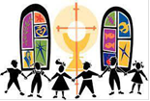
Weekend Ministries October 18-19

Readers Gift Bearers

Saturday Mary Murray Greg & Cathy MacGillivray
Ann MacLean

Sunday Lorraine Blakeney Steve & Janet Cormier
Sheila MacMillan

Faith Formation:
Classes have begun and will run Sundays from 10:30-11:30am following the Mass at 9:30am. Registration fees are $10 per child, $25 for three or more in the same family. If you have a son or daughter who has already participated (in a home program or in-person sessions) in Primary to Grade 7 you do not have to fill out a registration sheet. Only those new to the program will need to fill out a registration sheet. Registration sheets are located on the tables in the Gathering Area and at the ramp door. The completed sheets can be placed in the collection baskets, left on the tables, or dropped off at the office between 10am and 4pm Tuesdays to Fridays. Contact Pat Gillis at patgillis78@hotmail.com or phone 902-922-2843 to register for this year’s program. Please Note: When all the registration sheets are collected classes will be determined.

Weekly Collection October 4/5
Envelope Collection $2,706.00
Loose Collection $179.00
E-Transfers $265.00
PAD Income (averaged for 4 weeks) $1,080.25
Total $4,230.25
Average Weekly Expenses (estimate) $3,950.00
Surplus this week $280.25
Year to date position $4,994.48
Needs of Canadian Church $55.00
Christmas Offering $150.00
Faith Formation $45.00
Hall Rental $150.00

Currently, there are 33 active PAD contributors.
Thank-you very much for your continued generosity!

PLEASED BE ADVISED OF WORK BEING DONE ON THE RAMP

The ramp going up to the side door of St. John the Baptist Church is in the process of being repaired and will be out of commission for a period of time. (Due to unforeseen circumstances, the job will be taking longer than anticipated.) We apologize for this delay. For those of you who have mobility issues but think you can manage the stairs at the other entrance, there will be someone at the church to assist you. Again, we apologize for this delay and thank you for your understanding.

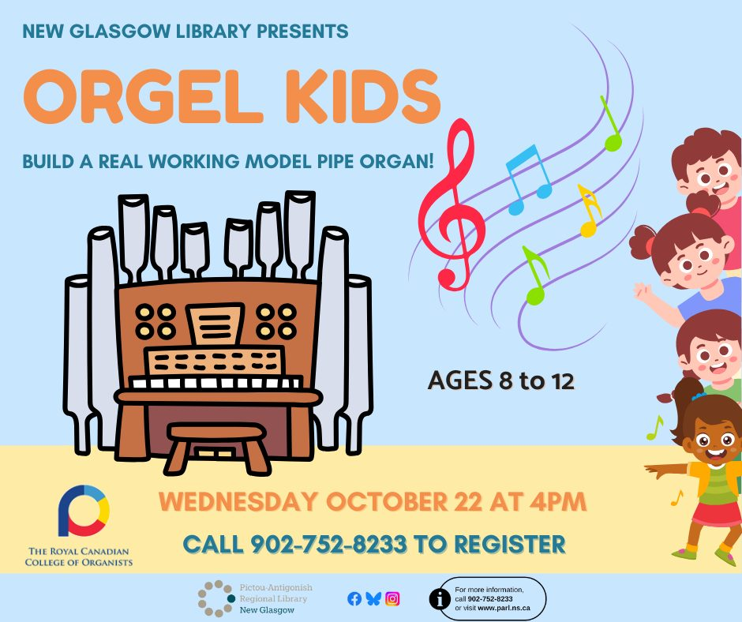

This presentation at New Glasgow Library, in partnership with the Royal Canadian College of Organists (RCCO) is being hosted by our own organist, Mark MacKenzie! As noted on the poster, call 902-752-8233 for more information and to register or visit www.parl.ns.ca.

The Catholic Register has launched its first podcast, REGISTERED.
Hosted by Editor Mickey Conlon with Reporters Quinton Amundson and Luke Mandato, each episode will feature a roundtable discussion on the headlines and events making waves in the Catholic community. Episodes of REGISTERED are available now at podcast.catholicregister.org. New episodes will be released weekly.

Development and Peace – Fall/2025 – Key Campaign Dates
August 2025 - Campaign launch on our website - October 4 – National launch website;
Sep – Oct – On line and in person training workshops across Canada
Fall 2025 – Be Pilgrims of Hope: Organize walks (devp.org/walk) and sign the petition (devp.org/debt). Nov 10 – 21– Our delegation attends the COP30 in Brazil
Nov 16 – Jubilee of the Poor - Day of Global mobilization to “Turn Debt Into Hope”, the ideal time to organize a walk or “Relay Of Hope” (devp.org/relay)
January 6, 2026 – End of the Jubilee and closing of the Holy Door (Deadline for collecting signatures and sent to Montreal Office.)
If anyone wishes to join me on D&P to represent our parish, please reach out at (902) 755-1345. Berkley DeCoste. Your interest, prayers and support are very much appreciated!

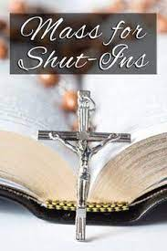

Mass for Shut Ins will return for Season 63 this month.
Recorded Masses are available for viewing on our diocesan website: https://www.antigonishdiocese.com/mass-for-shut-ins/
and YouTube channel: https://www.youtube.com/channel/UCPYevnyrNU6zIWHDh8KJ71w

World Mission Sunday 2025 is NEXT SUNDAY, October 19th , and the theme is "Missionaries of Hope Among All Peoples," a message originally from Pope Francis and carried forward by the new Pope Leo XIV. The theme emphasizes hope as the central message for the Jubilee year, highlighting the universal vocation of Christians to spread hope by following Christ's example. Pope Leo XIV, having served as a missionary bishop in Peru, brings personal experience to the theme, which underscores the importance of supporting mission territories worldwide through prayer, sacrifice, and giving.
• • Theme: "Missionaries of Hope Among All Peoples".
• • Pope Francis's message: He initiated the theme before his passing, emphasizing that hope is the heart of the Christian mission.
• • Pope Leo XIV's message: He has embraced and reinforced the theme, drawing on his personal missionary experience in Peru to give it renewed urgency.
• • Core message: The theme encourages all Christians to be messengers of hope, united in their vocation to support the missionary work of the Church.
• • How to participate: You can participate through prayer, sacrifice, and by donating to support the Church in mission territories.
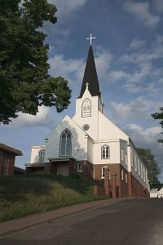
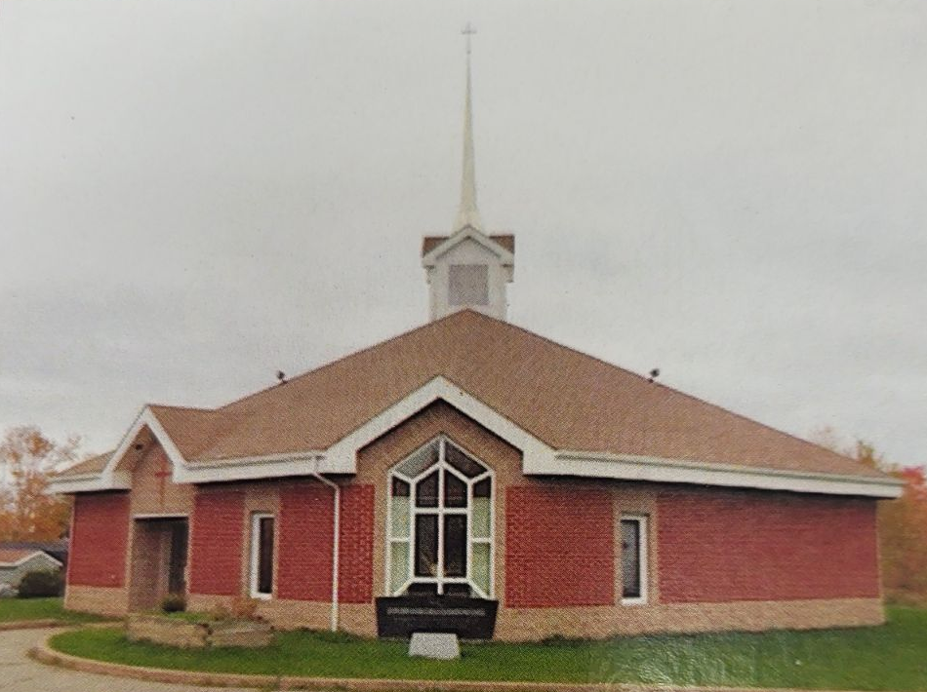

St. John the Baptist Church Our Lady of Perpetual Help Church
Masses: Saturdays at 4pm Mass: Sundays at 11:30am
and Sundays at 9:30am

