|  |  |  |
| --- | --- | --- |
| **October 2025 – Our Clergy** | | |
| **We** | **1** | Pope Leo XIV |
| **Th** | **2** | Bishop Wayne Kirkpatrick |
| **Fr** | **3** | Seminarians |
| **Sa** | **4** | Candidates to Permanent Diaconate |
| **Su** | **5** | Fr. Angus MacGillivray |
| **Mo** | **6** | Fr. Donald MacGillivray |
| **Tu** | **7** | Fr. George MacInnis |
| **We** | **8** | Fr. Duncan MacIsaac |
| **Th** | **9** | Fr. Joseph MacKenzie |
| **Fr** | **10** | Fr. Colin MacKinnon |
| **Sa** | **11** | Fr. Dan MacLennan |
| **Su** | **12** | Fr. Allan MacMillan |
| **Mo** | **13** | Fr. Everett MacNeil |
| **Tu** | **14** | Deacon Lorne MacNeil |
| **We** | **15** | Fr. Tom MacNeil |
| **Th** | **16** | Fr. Norman MacPhee |
| **Fr** | **17** | Fr. Albert MacPherson |
| **Sa** | **18** | Fr. Gary MacPherson |
| **Su** | **19** | Fr. Allan MacPhie |
| **Mo** | **20** | Fr. Albert Maroun |
| **Tu** | **21** | Deacon Duncan McMaster |
| **We** | **22** | Deacon Barry Miller |
| **Th** | **23** | Fr. Eugene Morris |
| **Fr** | **24** | Fr. John Morrison |
| **Sa** | **25** | Fr. Douglas Murphy |
| **Su** | **26** | Deacon Greg Murphy |
| **Mo** | **27** | Fr. Paul Murphy |
| **Tu** | **28** | Fr. Jonathan Nnajiofor |
| **We** | **29** | Fr. Anthony O’Connor |
| **Th** | **30** | Fr. Godwin Obike |
| **Fr** | **31** | Fr. James Oliver |



***Daily Prayers***

*Diocese of Antigonish*

**Please Pray for a Clergy**

**and Community Each Day**

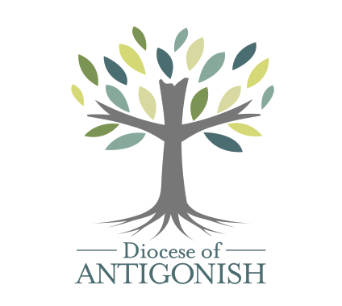

***Let us pray for priests and deacons:***

**The Holy Father**

*Fill him with your grace, Lord.*

**Our Bishop** **Those who are worried**

*Give him your gifts, Lord Give them peace, Lord*

**Diocesan Priests and Deacons** **Those who are old**

*Never leave them, Lord Sustain them, Lord.*

**Priests in seminary work**  **Those who are young**

*Give them your wisdom, Lord Impel them for your glory, Lord.*

**Those in hospital work**  **Those who are alone**

*Give them constancy, Lord Accompany them, Lord.*

**Those who are ill**  **Missionary Priests**

*Heal them, Lord. Protect them, Lord.*

**Those who are in danger**  **Those who preach**

*Deliver them, Lord. Enlighten them, Lord.*

**Those who are weak**  **Those who direct souls**

*Strengthen them, Lord. Instruct them, Lord.*

**Those who are poor** **Parish priests**

*Relieve them, Lord Give them prudence, Lord.*

**Those who are zealous** **On all the Church**

*Help them, Lord.* ---*Lord, have mercy*

|  |  |  |
| --- | --- | --- |
| **October 2025 – Our Communities** | | |
| **We** | **1** | Heatherton |
| **Th** | **2** | Ingonish |
| **Fr** | **3** | Inverness |
| **Sa** | **4** | Iona |
| **Su** | **5** | Johnstown |
| **Mo** | **6** | Judique |
| **Tu** | **7** | L’Ardoise |
| **We** | **8** | Lakevale |
| **Th** | **9** | Larry’s River |
| **Fr** | **10** | Lincolnville |
| **Sa** | **11** | Lismore |
| **Su** | **12** | Little Bras d’Or |
| **Mo** | **13** | Little Dover |
| **Tu** | **14** | Lochaber |
| **We** | **15** | Louisbourg |
| **Th** | **16** | Louisdale |
| **Fr** | **17** | Lower River Inhabitants |
| **Sa** | **18** | Mabou |
| **Su** | **19** | Main-à-Dieu |
| **Mo** | **20** | East Margaree |
| **Tu** | **21** | North East Margaree |
| **We** | **22** | Southwest Margaree |
| **Th** | **23** | Marion Bridge |
| **Fr** | **24** | Maryvale |
| **Sa** | **25** | Membertou |
| **Su** | **26** | Monastery |
| **Mo** | **27** | Mulgrave |
| **Tu** | **28** | New Glasgow |
| **We** | **29** | New Waterford |
| **Th** | **30** | North Sydney |
| **Fr** | **31** | Paq’n’kek |

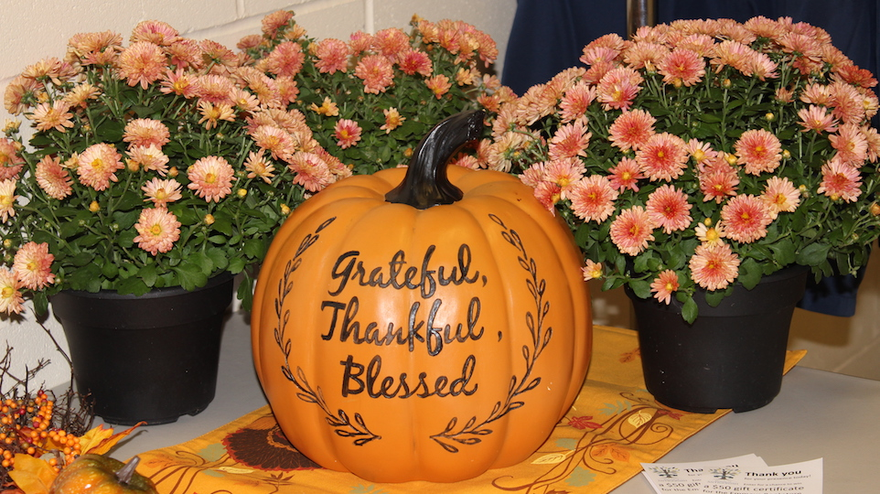

Embracing Father,  
You grace each of us with equal measure in your love.  
Let us learn to love our neighbours more deeply,  
so that we can create  
peaceful and just communities.  
Inspire us to use our creative energies  
to build the structures we need  
to overcome the obstacles  
of intolerance and indifference.  
May Jesus provide us the example needed  
and send the Spirit to warm our hearts for the journey.  
Amen

**—from Being Neighbor: The Catechism and Social Justice**

<https://www.usccb.org/prayer-and-worship/prayers-and-devotions/prayers/prayer-for-community>

*We invite you to use these prayers, offer your own prayers, or offer up Mass, Fasting, Eucharistic Exposition, Rosary. Holy Hour or other devotions. Thank you for helping to spread God’s healing love.*